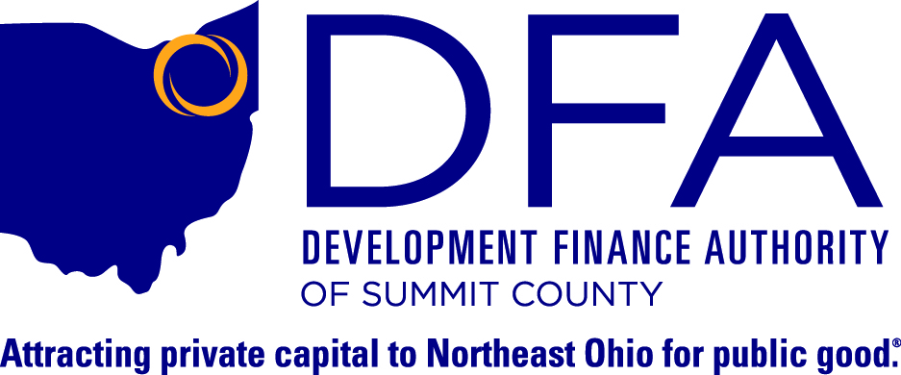

**For Immediate Release: Contact:**

January 31, 2017 Christopher Burnham

President

330.762.4776

**Development Finance Authority of Summit County**

**Announces Year-End Summary of**

**Community Economic Development Finance Activity**

*Akron, Ohio* – 2016 was a very busy and successful year for the Development Finance Authority of Summit County (DFA) and its Certified Development Entity, the Development Fund of the Western Reserve (DFWR). In 2016, the DFA and DFWR provided financing in the amount of $55,315,000 for twelve projects located in eight Ohio Counties, retaining/creating 1,094 jobs while leveraging $32,715,000 in additional funding sources.

During 2016, clients included the Village of Seville, Conexus, Summit County Land Bank, Bridge Park Development, Family & Community Services/AxessPointe, City of Fairlawn, Youngstown YMCA, Oberlin College, Lincoln Electric Welding Technology Center, Ronald McDonald House of Akron, and GreatWave Broadband Services.

This work could not be possible without the collaboration of our many partners, who include Brennan, Manna & Diamond, LLC, Roetzel & Andress, LPA, Brouse McDowell, LPA, Vorys, Sater, Seymour and Pease, LLP, DiPerna Advisors, Novogradac & Company, LLP, FirstMerit (now Huntington Bank), Chase Bank, KeyBank, Capital One, US Bank, Dudley Ventures, Finance Fund, Toledo-Lucas County Port Authority, Portage County Port Authority, Columbus-Franklin County Finance Authority, and the County of Summit.

*###*